COURSE SPECIFICATION

Course Aim and Title | BA (Hons) Football Coaching
Intermediate Awards Available | Certificate of Higher Education (Cert HE)  Diploma of Higher Education (Dip HE)
Teaching Institution(s) | Global Institute of Sport (GIS)
Alternative Teaching Institutions  (for local arrangements see final section of this specification) | N/A
UEL Academic School | School of Health, Sport and Bioscience
UCAS Code | TBC
Professional Body Accreditation | N/A
Relevant QAA Benchmark Statements | QAA Subject Benchmark Statement for Events, Hospitality, Leisure, Sport and Tourism (2019), and Business and Management (2023).
Additional Versions of this Course | N/A
Date Specification Last Updated | February 2026

Course Aims and Learning Outcomes
Course Overview

The BA (Hons) Football Coaching is a comprehensive distance learning degree designed for aspiring and current coaches who want to develop their expertise while balancing work, coaching commitments, and personal responsibilities. Delivered flexibly online, this course enables students to study from anywhere in the world while applying learning directly within their own coaching environments.

The course integrates academic theory, applied coaching practice, leadership development, and industry engagement. Underpinned by employability and industry principles, the programme supports not only academic success but also personal resilience, reflective capacity, professional confidence, and long-term career sustainability within football.

This focused course connects learning to real coaching contexts, encouraging students to embed knowledge into their current practice whether working in grassroots, academies, community programmes, or elite settings.

Course Aims:
Equip students with a comprehensive understanding of contemporary, evidence-based coaching practices, enabling them to critically evaluate research and apply theory effectively within diverse football contexts.

Provide students with the practical skills, technical knowledge, and experiential learning opportunities required to design, deliver, and evaluate coaching sessions across grassroots, academy, and elite environments.

Develop students’ communication, leadership, analytical, and problem-solving abilities, preparing them for employment within football organisations and related professional settings.

Encourage independent learning, reflective practice, and professional resilience, enabling graduates to engage with industry networks, adapt to evolving coaching environments, and contribute as inclusive and ethical practitioners

What you will learn

Course Learning Outcomes:

- Prepare students for a coaching career within football clubs or organisations.
- Provide students with a detailed knowledge of the external contexts in which football coaching takes place.
- Enable students to develop the communication, analytical and problem-solving skills required for a career in football industry.
- Develop students’ understanding of contemporary approaches to evidence-based practice in football coaching.
- Develop students’ understanding of, and experience in, the application of football coaching skills, analysis, talent development and management.
- Provide students with opportunities to engage with the football industry throughout the course, utilising distinctive delivery locations and GIS relationships.
- Develop relevant skills and attributes which enhance employability and equip graduates to become impactful global and inclusive citizens as well as reflective independent and collegial lifelong learners.
- To describe and comment upon aspects of current research, or equivalent advanced scholarship, in football coaching
- The ability to manage their own learning, and to make use of scholarly reviews and primary sources (for example, referred research articles and/or original materials appropriate to the discipline)

Learning and Teaching / Assessment
At GIS, our learning and teaching approach is structured, student-focused, and designed to support the delivery of high-quality education across all disciplines. It reflects our commitment to creating meaningful learning experiences that integrate theory, promote active engagement, and foster reflection and personal growth.
This learning and teaching model promotes purposeful, engaging, and inclusive learning through a combination of microlearning and active learning strategies. It emphasizes structured delivery, allowing students to engage with content in manageable and meaningful ways that promote deeper understanding, learner autonomy, and practical skill development.
Figure 1. GIS Learning and Teaching Cycle (2025):
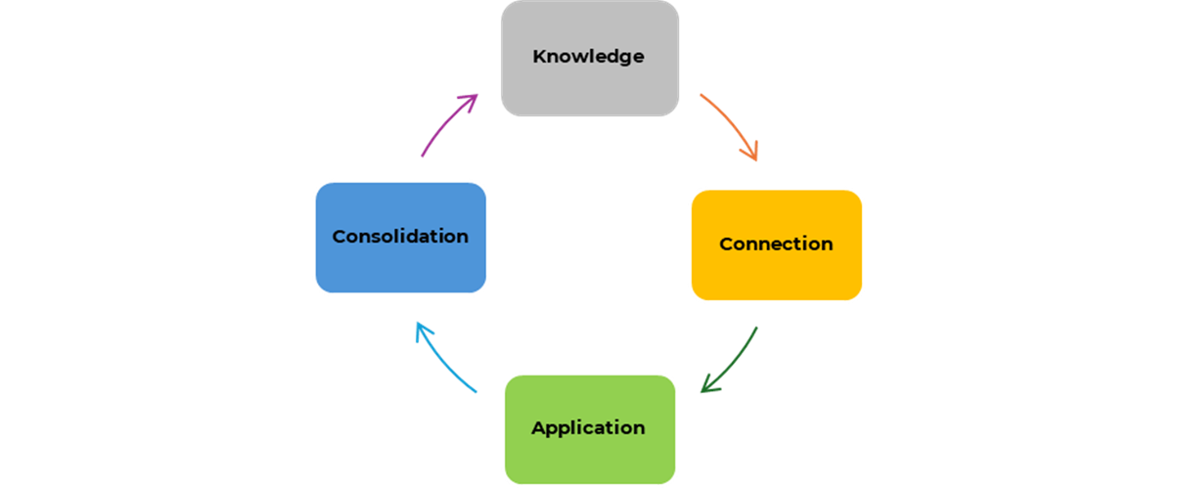
1. Knowledge (Core foundation)
Knowledge is developed and assessed through:
- Core academic literature, journals, books, and models aligned with module content and learning outcomes.
- Introduction to key concepts, definitions, and principles.
- Structured explanations of topics to provide foundational understanding.
- Contextual knowledge needed to support deeper exploration and application.

2. Connection (Thinking Skills – helping bring theory to life)
Critical thinking and analytical skills are developed and assessed through:
- Case studies
- Videos and animations
- Podcasts and audio explanations
- Interactive simulations or clickable definitions
- Guest speakers (live or recorded)
These tools help students connect theoretical knowledge to real-world contexts, encouraging deeper cognitive engagement.
3. Application (Practical Skills – putting leaning in practice)
Practical and professional skills are developed and assessed through:
- Activities that bridge theory and practice or challenge existing assumptions
- Interactive tasks, problem-solving exercises, and hands-on learning
- Opportunities to apply concepts in real or simulated environments.
- Practice-based activities that reinforce understanding through experimentation.
- Tasks that promote reflection and active participation

4. Consolidation (Reinforcement - Skills for Life and Work)
Transferable and lifelong learning skills are developed and assessed through:
- Knowledge checks, reflections, quizzes (Declarative Knowledge)
- Collaborative opportunities to discuss, debate, and refine learning with peers and tutors (Procedural Knowledge)
- Live and classroom sessions that promote critical thinking and synthesis for long-term knowledge retention and personal development (Conditional Knowledge)
- Peer-to-peer learning and knowledge sharing to enhance communication and teamwork.

Learning on the BA (Hons) Football Coaching programme progresses in depth, complexity, and independence from Level 4 to Level 6. At Level 4, students are introduced to foundational coaching principles, key theoretical concepts, and basic practical applications within familiar contexts. At Level 5, learning becomes more analytical and applied, with students critically engaging with coaching practices, exploring diverse environments, and beginning to integrate theory with practice through reflection and problem-solving. By Level 6, students are expected to demonstrate autonomy and criticality, synthesising research, evaluating complex coaching scenarios, and applying advanced, evidence-based approaches within their own professional contexts, while operating as reflective, independent practitioners prepared for sustained careers in the football industry.

Work or Study Placements
N/A

Course Structure
All courses are credit-rated to help you to understand the amount and level of study required.

One credit is equal to 10 hours of directed study time (this includes everything you do e.g. lecture, seminar and private study).

Credits are assigned to one of 5 levels:

3 Equivalent in standard to GCE 'A' level and is intended to prepare students for year one of an undergraduate degree course
4 Equivalent in standard to the first year of a full-time undergraduate degree course.
5 Equivalent in standard to the second year of a full-time undergraduate degree course.
6 Equivalent in standard to the third year of a full-time undergraduate degree course.
7 Equivalent in standard to a Masters degree.

Courses are made up of modules that are each credit weighted.

The module structure of this course:
Level | Module  Code | Module Title | Core/Option | Credit Weighting
4 |  | Introduction to Academic and Professional Development in Sport (Mental Wealth) | Core | 20
4 | SE4036 | Introduction to Football Coaching | Core | 20
4 | SE4037 | Introduction to Talent Development | Core | 20
4 | SE4040 | Football in the Community | Core | 20
4 |  | Introduction to Football Management | Core | 20
4 |  | Coaching in Foundation Phase (Youth Zone 1) | Core | 20
5 | HR5016 | Employability & Enterprise (Mental Wealth) | Core | 20
5 |  | Match & Performance Analysis | Core | 20
5 |  | Managing Teams and Individuals | Core | 20
5 | SE5033 | The Reflective Coach | Core | 20
5 | SE5032 | Coaching in Youth Development Football | Core | 20
5 |  | International Talent Management | Core | 20
6 |  | Talent Identification & Scouting | Core | 20
6 |  | Developing a Game Model | Core | 20
6 | SE6032 | Coaching in Elite Environments | Core | 20
6 | TM6052 | Professional Project | Core | 40
6 | HR6032 | Engagement with the Global Sports Industry (Mental Wealth) | Core | 20
Further details about the delivery of this course:
This course is only taught online.

The overall credit-rating of this course is 360 credits. If for some reason you are unable to achieve this credit you may be entitled to an intermediate award, the level of the award will depend on the amount of credit you have accumulated. You can read the University Student Policies and Regulations on the UEL website.

Course Specific Regulations
None

Typical Duration
The expected duration of this Undergraduate course is three years.

A student cannot normally continue study on a course after 4 years of study in full time mode unless exceptional circumstances apply and extenuation has been granted.

Further Information
More information about this course is available from:
- The GIS web site (https://gis.sport/)
- The course handbook
- Module study guides
- UEL Manual of General Regulations
- UEL Quality Manual

All GIS programmes are subject to thorough course approval procedures before UEL allow them to commence. We also constantly monitor, review and enhance our courses by listening to student and employer views and the views of external examiners and advisors.
Additional costs:
- Technology – Students are required to have access to a laptop, desktop computer or mobile device to support learning and assessment. The costs will be dependent on your choices. The GIS virtual learning environment is compatible with mobile devices, including tablets. However, students will need a reliable internet connection in order to view the content as part of their course.
- Books, Journals and Periodicals – Books will be available to access within the GIS and UEL e-library. If students wish to purchase books they can do so, however this is not a requirement of the course.
- Accommodation and Travel – If students opt to attend in person events, students are responsible for arranging their own accommodation and travel, if it is required. Costs will be dependent on student choice of accommodation and travel.

Alternative Locations of Delivery
This course is also taught online by the Global Institute of Sport (GIS) and is awarded by the University of East London.

Students will have the opportunity to enhance their studies by attending GIS Global Summits throughout the duration of their studies, held at locations such as UK, Miami, Melbourne and Toronto. Further information on dates and activities available as part of the summits will be provided during your studies. Additional costs will apply to participate in Global Summit activities

